Assignment - 4

|  |  |
| --- | --- |
| Assignment Date | 20 October 2022 |
| Student Name | Saai Prasath.R |
| Team ID | PNT2022TMID16490 |
| Maximum Marks |  |

Question 1:

Pull an image from docker hub and run it in docker playground.

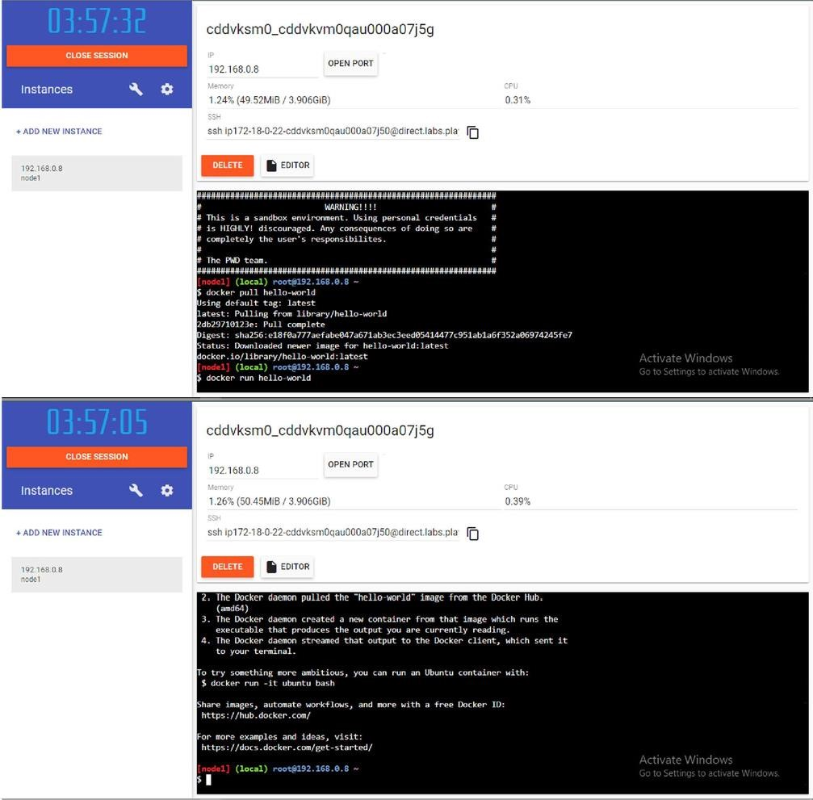

Question 2:

Create a docker file for the jobportal application and deploy it in Docker desktop application.

DOCKERFILE:

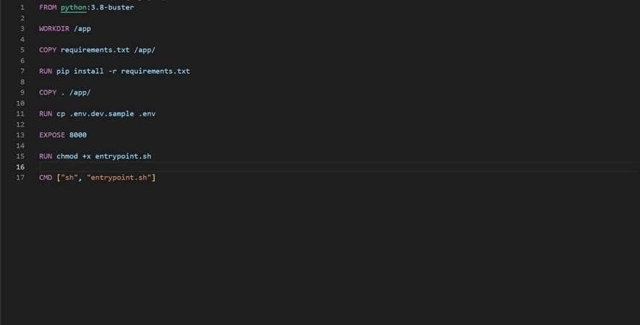

DEPLOYMENT OF JOBPORTAL APPLICATION:

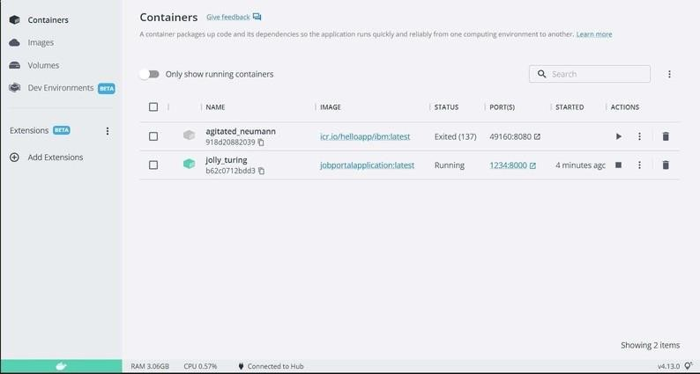

OUTPUT:

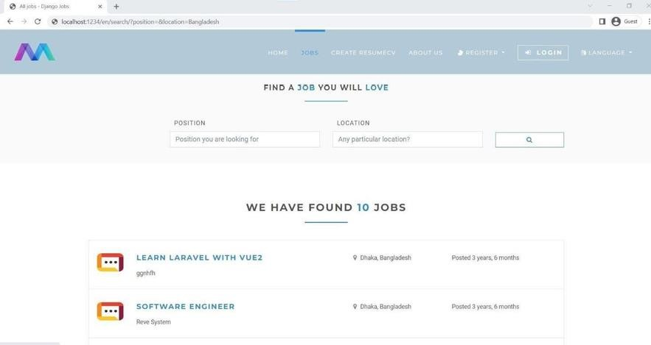

Question 3:

Create a IBM container registry and deploy helloworld app or jobportal app.

IBM CONTAINER REGISTRY DEPLOYMENT:

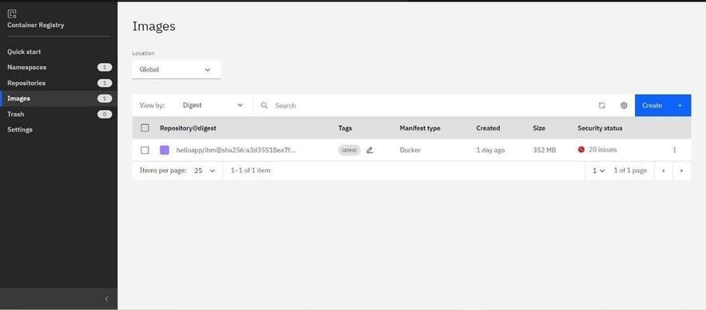

OUTPUT:

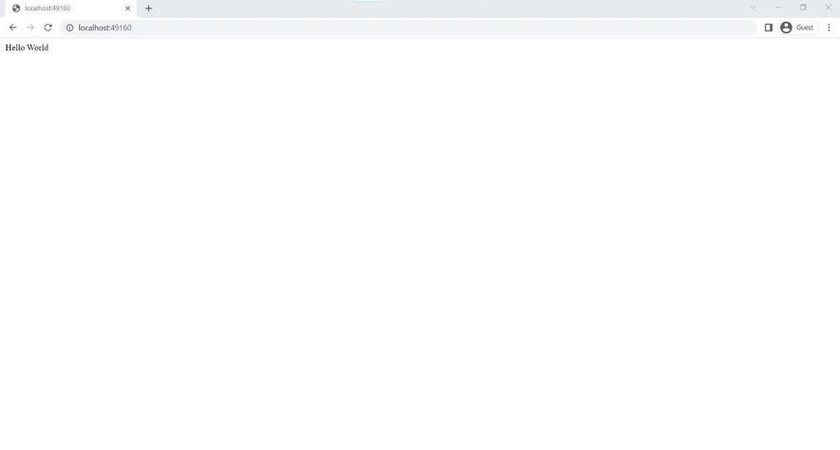

Question 4:

Create a Kubernetes cluster in IBM cloud and deploy helloworld image or jobportal image and also expose the same app to run in nodeport.

Creating kubernetes cluster in IBM cloud and exposing nodeport:

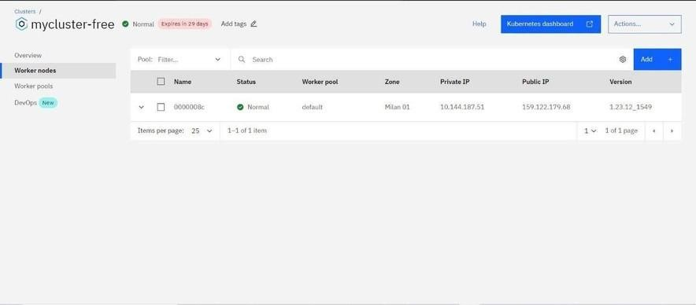

Output:

